The Coordination of Pairs

In sentences where we have conjoined embeddings like example 1 from UD, according to the UD’s rule of thumb, the first constituents, here ‘Marie’ and ‘to Paris, are the main constituents of the sentence. The rest conjoined constituents, here ‘Miriam to Prague’, form a phrase in which the main constitnuent present, here ‘Miriam’, is raised to head of the phrase and is conjoined to the verb of the sentence (‘went to’). The rest, here ‘Prague’, go to this raised head (‘’Miriam’) in an orphan relationship.

1 | 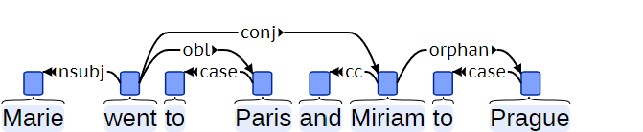

This analysis fits very well with languages like English which have the verb second. However, in some languages, it causes conflicts with another UD rule of thumb that the conjoined construction shall not proceed the head. Consider the following example from the Turkish corpus.

2 | 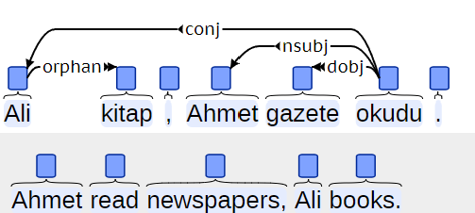

The above analysis differs (2) in two parts. On the one hand, the main constituents are not the first ones, namely Ali and kitap, but the last ones, Ahmet and gazete. This analysis is probably suggested as to make the Ahmet gazete okudu a complete sentence comparable to the English example above (1) “Marie went to Paris”. This analysis ignores the UD’s assumption that the head of the conjunct relation is the first conjunct and the rest depend on it via the conj relation. Then, here we have a conjunct (Ali) preceeding its head (okudu).
The situation in Persian is also the same as the verb usually appears at the end of the sentence. In the following example (3.1–3.3), we have three phrases conjoined. So, if one follows the analysis in example 2 above, taking the last one (3.3) the complete sentence and the first (3.1) and the second (3.2) conjoined to it, the same problem of the conjuncts referring to proceeding element arises. Moreover, an agreement problem will also arise in the complete phrase as the verb is plural but the last subject is singular. On the other hand, if the constituents in the first phrase (3.1) are assumed as the main constituents and the rest conjoined, like it is the analysis in example 1 above, still the orphans of the second (3.2) and the third (3.3) phrases shall be raised to the head position and go to the root of the sentence (ēstēnd) which is only spelled out after these orphans. Then, the error will be that these orphans proceed their parents.

3.1 | u=š | wahman | orwahišt | ud | šahrewar | az | dašn
 | and= pc.3sg | Wahman | Ardwahišt | and | Šahrewar | from | right

3.2 | spandarmad | hordad | amurdad | az | hōy
 | Spandarmad | Hordad | Amurdad | from | left

3.3 | srōš | pēš | ēstēnd
 | Srōš | In front | stand.3pl.nonpst
 | And Wahman, Arwahišt, and Šahrewar stand on his right, and Spandarmad, Hordad, and Amurdad on his left, and Srōš in the front.

This recent analysis, in which orphans proceed parent, in some cases creates crossing lines in the syntactic tree and causes non-projectivity of the nodes. For example, in the 4,

4.1 | ēn | gyāg | ast | kē | zarābād
 | this | place | be there.3sg.nonpst | someone who | Zarābād

4.2 | ast | kē | rāzag | bašn
 | be there.3sg.nonpst | someone who | Rāzag | peak

4.3 | ud | ast | kē | karā | xwānēd
 | and | be there.3sg.nonpst | someone who | Karā | call.3sg.nonpst

There is someone who calls this place Zarābād, There is someone who (calls it) Rāzag peak, and there is someone who (calls it) Karā (GBd

In the above sentence (4), ēn gyāg is a dislocated topic for the root which is the existential verb ast ‘there is’. The repetitions of the root shall be conjoined to it, while the root of the clausal subject, namely the verb xwānēd has several conjunctions which are basically open clausal complements raised to the head of the phrase. Therefore, the conjunctions of the root of the sentence refer to the left while the conjunctions of the clausal subject refer to the right, and the word order is in a way that these dependency lines cause crossings in the syntactic tree.

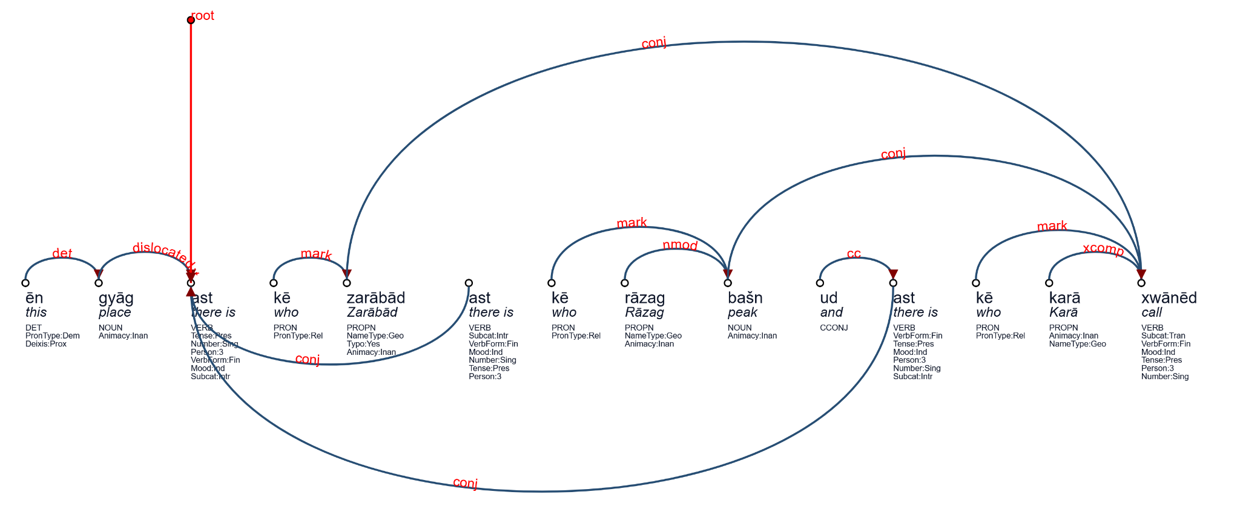

https://universaldependencies.org/en/dep/orphan.html
https://universaldependencies.org/tr/dep/orphan.html
At least in written texts.

